I.E JOSÉ MIGUEL DE RESTREPO Y PUERTA  COPACABANA-ANTIOQUIA | READING COMPREHENSION ACTIVITY  TOPIC: SOCIAL VALUES  LEARNING GOAL: | DATE:
 |  | PERIOD:
 |  | COURSE:
 |  | TEACHER:

Instructions.

- Read the story
- Being able to express oneself orally
- Being able to express oneself in writing

The Little Turtle by Carmen Lodeiro.

This is the story of a little turtle who liked to play alone with her friends. She also loved to watch TV and play in the street, but she seemed to not have fun in the school.
For her it was very difficult to sit listening to her teacher. When her teammates and classmates took away her pencil or pushed her, our turtle was so angry that she would soon fight or insult them to the point that they excluded her from their games.
The turtle was very upset. She was angry, confused and sad because he could not control herself and did not know how to solve the problem.
One day she met a wise old turtle that was three hundred years old and lived on the other side of town. Then she asked: 'What can I do? I hate school. I cannot be good, even though I try, but I never can. Then the old turtle replied: 'The solution to this problem is in yourself. When you feel very upset or angry and you cannot control yourself, get inside of your shell (enclose a hand on the fist of the other and hide the thumb as if it was the head of a turtle in its shell).
You can calm down in there. When I hide in my shell I do three things: First, I say to myself –Stop- then I breathe deeply once or more if I need to and, finally, I tell myself what is the problem. Then the two practiced together several times until our turtle said she was looking forward to the time to go to class to prove its effectiveness.
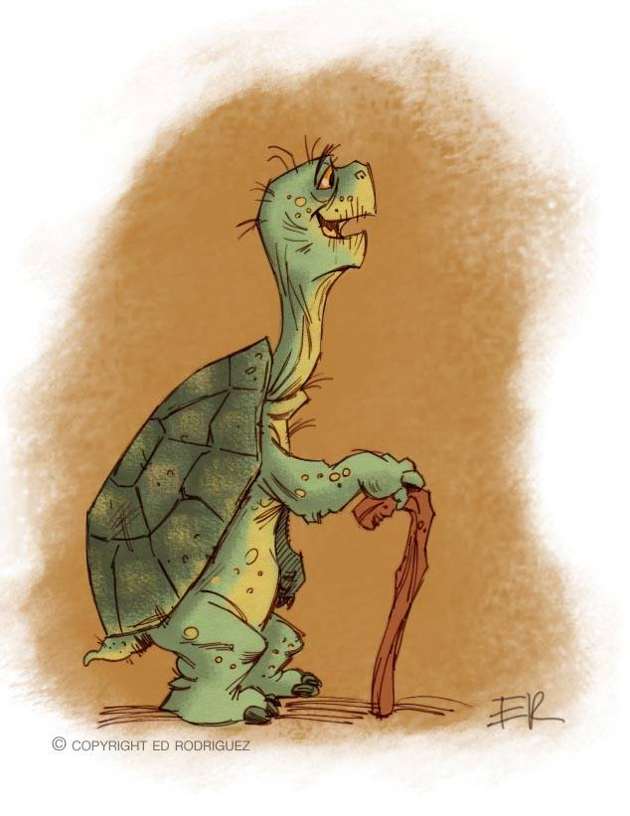
The next day, the turtle was in class when another boy began to bother her and when she began to feel the rise of anger inside, her hands began to heat up and the rhythm of her heart was racing, she recalled what her old friend had told her, she retreated inside, where she could be quiet with no one to bother her and thought about what she had to do.
After several deep breaths, she came out of her shell again and saw that her teacher was smiling. Our turtle practiced again and again. Sometimes she succeeded, sometimes not, but, little by little, the act of retreat into her shell was helping her to control herself. Now that she has learned she has more friends and friends and enjoys going to school.

Retrived from: http://cometacarmenlodeiro.blogspot.com/2013/03/cuento-la-tortuga-para-trabajar.html

